**An outline itinerary for Taste of Nepal Tour**

**Nepal Panorama tour 7 night 8 days, Kathmandu - Nagarkot Pokhara and Chitwan**

**Day 1:**Arrival Kathmandu, pick up from airport by Earthbound Expeditions representative and Check into hotel rest day

**Day 2 :**Kathmandu sightseeing and Nagarkot :  After brekfast go to see Swayambhu nath known as Monkey Temple - one of the oldest Buddhist Stupa in Valley,  Shiva Temple of Pashupatinath - the cremation places of Hindu death body, Boudhanath- the biggest Buddhist temple, Patan Durbar Square- the finest example of metal and stone carving back to 14th century,  later we drive up to Nagarkot ( 7, 200ft) - a beautiful hill station, which in a clear day provides magnificent Mountain panorama, from Everest in the east to Annapurna in the west, eight of the world's tallest Mountain in a peaceful rural settings.

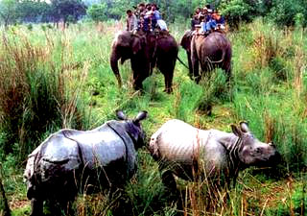

**Day 3 :  Early morning sunrise and mountain view and**drive to  Bhaktapur the World heritage town and later drive to Chitwan National Park by bus about 5 hours. Chitwan once the hunting ground of British and Nepalese aristocrats. Today, the animals - Elephant, Rhinoceros, Tiger, leopard and deer - are protected, not shot.  It is listed in UNESCO world heritage sights and one of the first finest National park in Asia.   
The greatest thrill here is to scout for wildlife on the back of an elephant.

**Day 4 :**  We spent Full day at Chitwan National Park  for the Jungle safari  activities includes jungle walk, elephant riding, village visit, canoeing, bird-watching, Elephant bathing etc.

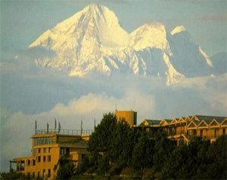

**Day 5:**After breakfast we drive to Pokhara - 200 km west of Kathmandu - at least 5 hours drive.  
Pokhara is a famous sightseeing point for travelers with beautiful lake and mountain ranges. One of the most beautiful lake cities in the world. Overnight in hotel.

**Day 6 : Early morning**drive to Sarangkot – 6500ft. a hill top view point for sunrise and close-up view of Annapurna & Fishtail Mountain.   
After breakfast full day in Pokhara excursions and sight-seeing in Pokhara : David’s fall,  boating in Phewa lake and temple visit. Stay in Pokhara.

**Day 7 :** After breakfast drive back to Kathmandu  by bus (or have option to fly USD 115 per person extra).  
A half-day shopping or free and enjoy a typical Nepali cultural show and dinner in evening.

**Day 8 :** Airport drive for departure to home.